XML2Graph

XML2Graph 1.0.0.8 Document

Table of Contents

Introduction 2

How To Use it? 2

Install and Launch XML2Graph 2

Import XML file 3

Export to TrendReport 4

Generate graphs 5

# Introduction

This tool is able to:

* Convert EVO performance test results which are in xml format to data in Excel workbook.
* Generate line graphs from the data in Excel workbook.

# How To Use it?

## Install and Launch XML2Graph

1. The tool can be installed by launching the setup.exe under the installation folder.

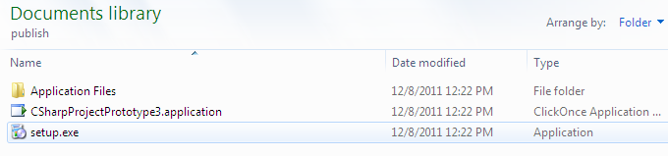

Figure : Installation

1. After installation, an XML2Graph icon will appear on your desktop. It can be launched by double-clicking the icon.

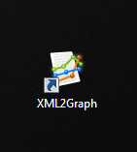

Figure :XML2Graph icon

1. After launching, it will take you to its main window.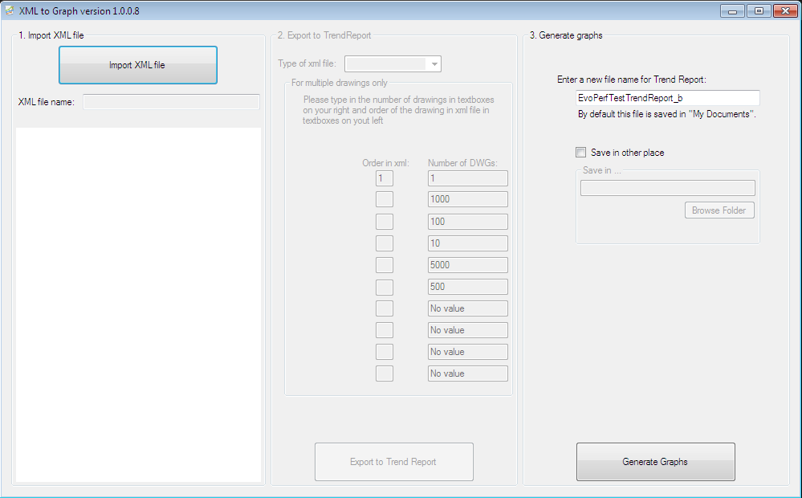

Figure : Main window

The main window is divided evenly into 3 parts. Part 1 and part 2 of this window are linked to each other while part 3 can be used individually.

The first part is “1. Import XML file”. It is used to import an xml file to XML2Graph. There are 3 xml files to work on, dealing with single and multiple drawings (for example: 1000 Dwgs, 100 Dwgs, 10 Dwgs, 5000 Dwgs, and 500 Dwgs), Single drawings on Windows 7 64 bit, and Single drawings on Windows XP 32 bit.

The second part is “2. Export to TrendReport”. It is used to export the data retrieved from xml file from part 1 to an Excel workbook which is used to save data for all EVO builds. It is disabled by default and can only be activated when part 1 is completed.

The third part is “3. Generate graphs”. It is used to generate line graphs from existing data in an Excel workbook. It is able to work on its own as it doesn’t depend on Part 1 and Part 2.

## Import XML file

1. Click the button “Import XML file” and search for the xml file in the “Open XML file” dialog. This dialog only displays file with xml format.
2. Select the xml file and click “Open” or double-clicking the file.
3. The xml file name will be displayed in the “XML file name” textbox and a preview of the content will also be displayed in the white area.
4. The import process is done and the part 2 is enabled now.

## Export to TrendReport

1. You can tell XMl2Graph what type of xml file you are working on by choosing the correct option in the “Type of xml file” drop list. The 3 options available are:
2. **Single and Multiple**: for xml files with single and multiple drawings only (1000, 100, 10, 5000, 500…)
3. **Windows XP 32bit**: for xml files with Windows XP 32 bit only.
4. **Windows 7 64bit**: for xml files with Windows 7 64 bit only.
5. If “Single and Multiple” is chosen, the “For multiple drawings only” box will be activated and you have to tell the application the order of the multiple drawings according to the xml file. Usually, the order of the xml file should be single drawings > 1000 drawings > 100 drawings > 10 drawings > 5000 drawings > 500 drawings. For this sequence, you can fill in the order in this way: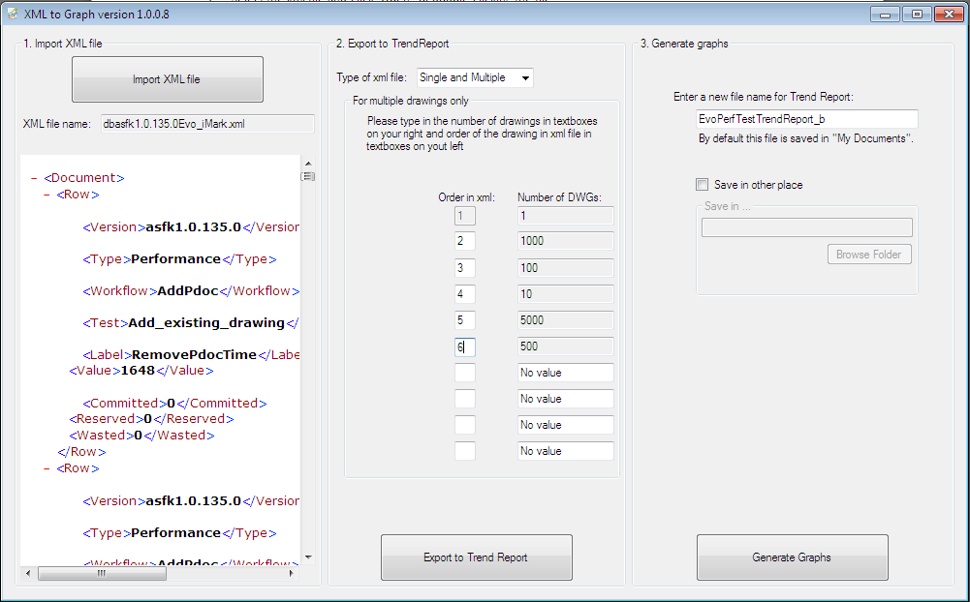

Figure : fill in the order of multiple drawings

1. If either “Windows XP 32bit” or “Windows 7 64bit” is chosen, the “For multiple drawings only” box will not be activated as it is not used for these 2 options. The 2 are only for single drawings.
2. Click the “Export to Trend Report” button and search for the trend report Excel workbook to store data. **This Excel workbook is only for data storing and should not contain any graphs**.
3. After clicking the Excel workbook to work on, the application will need around one minute to process and a message box will pop out saying that the xml file is exported to <Excel workbook filename>.

Note:

1. If there is any exception or error occurred, the application might not be able to be closed properly. In this case, please open “Task Manager” and close the “EXCEL.EXE” under “Processes” tab.
2. In the trend report Excel workbook, 1st column is used for test case names and 2nd is used for limit value and should be reserved for future use for both performance and capacity.

## Generate graphs

1. To generate graphs, you can enter a new name for the trend report according to the latest build you are working on in the “Enter a new file name for Trend Report” textbox.
2. By default, the trend report with graphs generated will be saved in “My Documents”. However, you can choose to save it in other places by checking the “Save in other place” option to activate the “Save in …” box.
3. In the activated “Save in …” box, you can choose the folder where you want your trend report to be saved in by just clicking the “Browse Folder” button.